I took a picture of the file path in explorer of my workspace folder
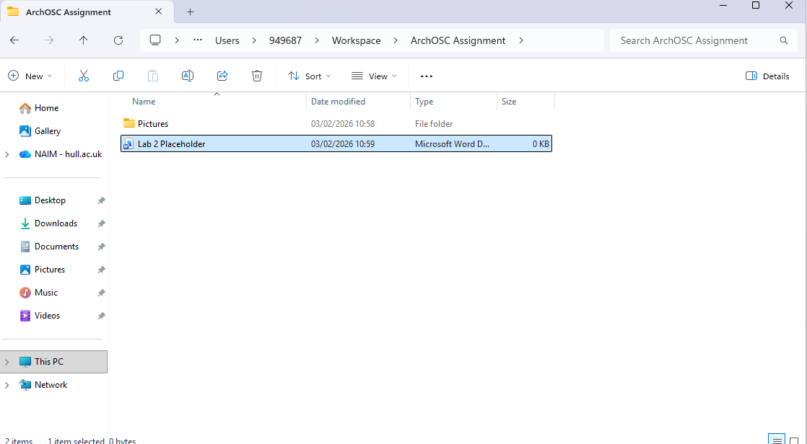
Here’s a picture of it.
I have initialised a repo of my project folder
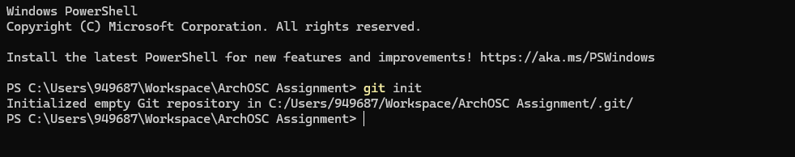
Heres a picture of it

I created a repository on GitHub called ARCHOS assignment

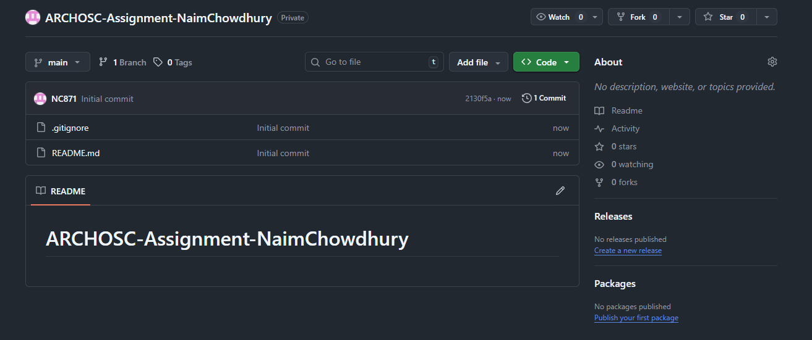

This is a picture of it

I linked my local repo to GitHub and pulled data from the origin main on github and below theres a screenshot.
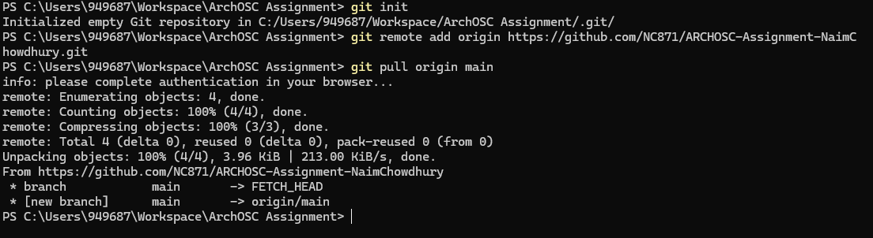

Created a website in visual studio in HTML to say my name
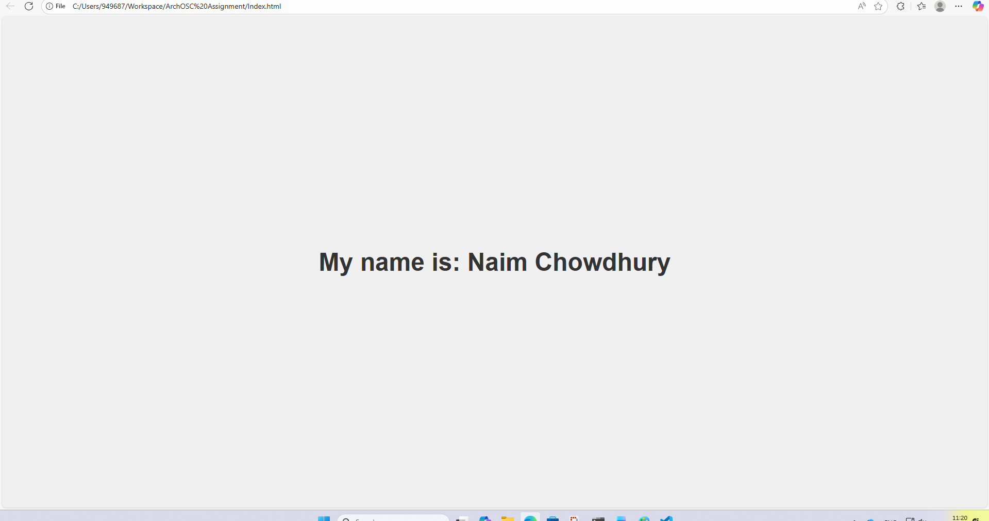

Commited my new files to github

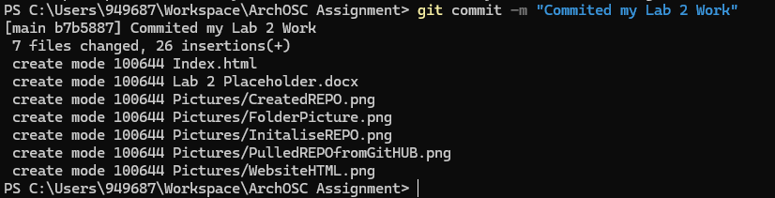

Pushed committed files onto github
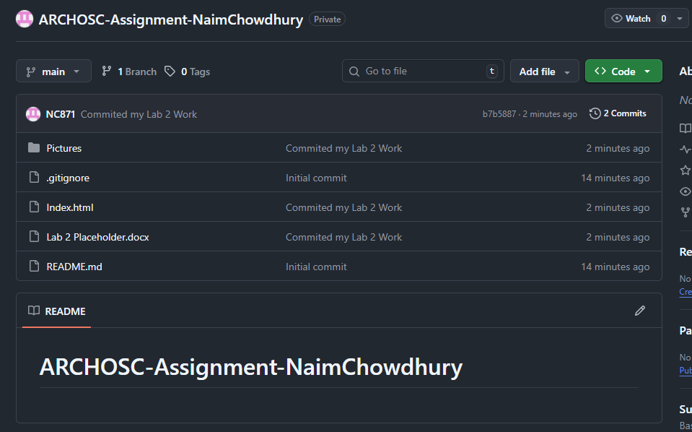

I changed the background colour to lime green and the text is set to red
